About this Document
This document is intended to be used as a supplement to the associated training video (e.g., “Lead Inquiry for Lead Providers”). It contains the same steps that are described in the video but provides the information in written format for additional reference.
This document is intended for the Lead Provider audience group.

About Lead Inquiry for Lead Providers
When a lead has been received by the Sparkroom application, it is scrubbed and processed, during which it is matched to a filter, target group and pricing group and defined as a "good" or "bad" lead with a verification code applied. The Lead Inquiry screen allows you to complete a variety of selection fields to search for leads which have completed this processing stage.
From the Lead Inquiry screen, once you have chosen your search criteria you can save the lead inquiry as a “view” which you can access from the View Management screen (under “Lead Inquiry Views”). (From there, you can rename, delete, make searchable, assign ownership, and share the view, as well as schedule its export to email and/or FTP).
In addition to “pulling” lead data from the Lead Inquiry screen, you can use Lead Inquiry to investigate individual leads. For example, you may want to search for leads that you sent to a specific lead buyer over a given time period, or pull all leads with a start date last month.
From the Lead Inquiry, you can also export the results of your lead search. It is easy to customize the columns that you want to include in your export. Once you have selected the columns to include/exclude in the export, you can select the format of the exported file as CSV or XLS.

Using Lead Inquiry as a Lead Provider
Task: To search for leads, investigate leads for a particular lead buyer over a given time period, save the view, and export the lead inquiry.
- From the navigation menu, select Operations > Lead Inquiry.
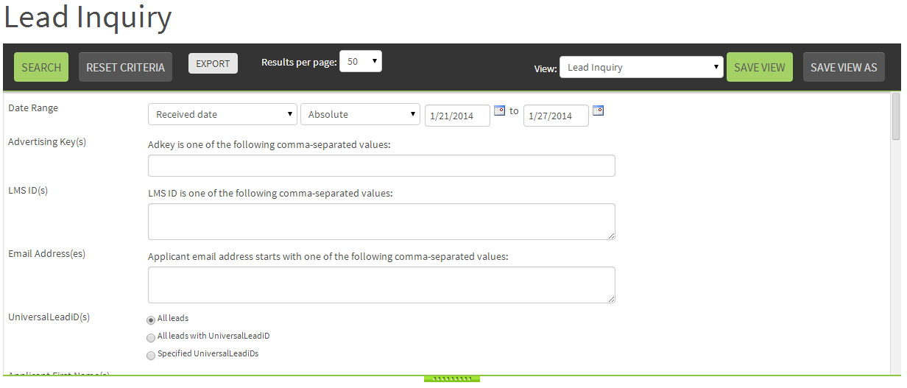
- Complete the selection criteria, as required, to specify the leads that you want to include in the generated results. In the example below, the lead provider selects all leads they sent to the lead buyer “Academy of Art University” in the current month.
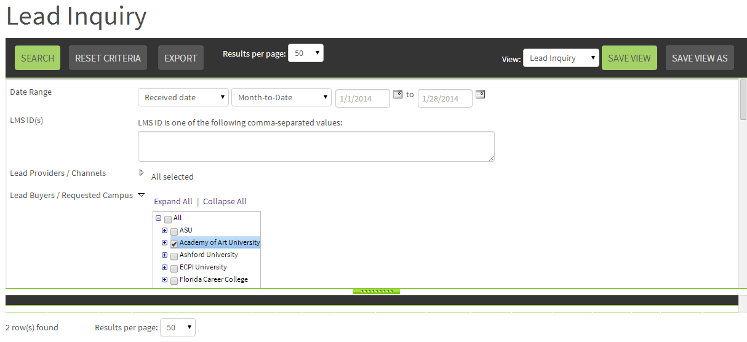
To save the lead inquiry as a “view” (based on the search criteria you selected above):
- Click Save As and then provide a name for the lead inquiry view. Once saved, the lead inquiry view becomes available from the View Management screen, from where you can schedule the view for automated delivery as well as perform other actions such as sharing and making the view searchable.
In the example below, the lead provider wants to save the lead inquiry view so they can generate it easily, and as frequently as required, using their preferred criteria. This way, the lead provider can assess the leads that have been received by the specified lead buyer in the current month on a frequent basis.
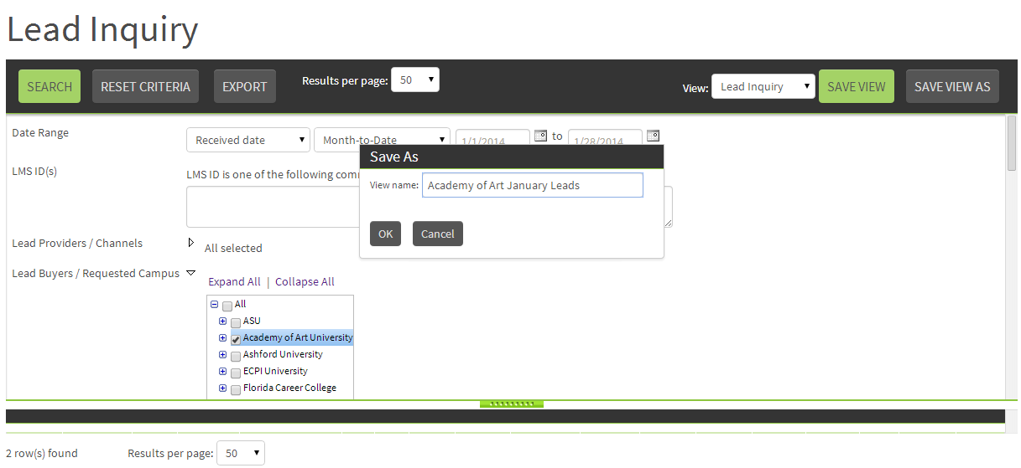
Note
Saving your lead inquiry as a view, and being able to access it from the View Management screen, will save you time by allowing you to generate the lead inquiry using your saved search criteria.
You can also save time by scheduling a lead inquiry for export via email and/or FTP from the View Management screen. This will enable you to receive a lead inquiry as a scheduled event (one time or recurring) using your saved search criteria.
For more information on working with views from the View Management screen, please refer to the video and training document “Sharing, Making Searchable, Finding, and Scheduling Views”.
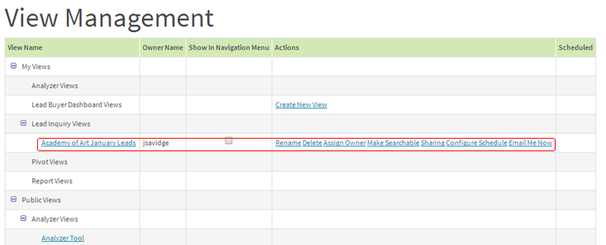
To view the lead inquiry search results on the screen:
- Click Search. The Results Panel appears, displaying the leads matching your search criteria. (Although all lead inquiry columns are displayed in the generated results, for information on adding and removing columns from the exported lead inquiry, see Steps 5 – 8 below).
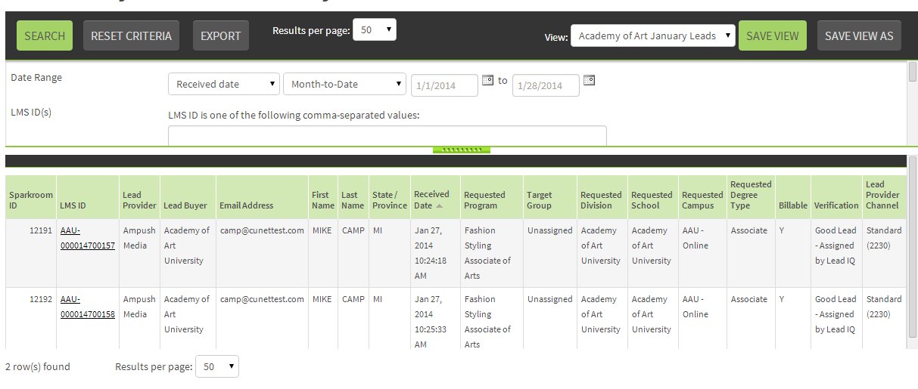
Note
Once the lead inquiry has been generated from the Lead Inquiry screen, to view more detailed information you can drill down to the Lead Details screen via the LMS ID column to view additional data. This lead data includes information such as fees, call center disposition, compliance and scoring results, and history. History allows you to view milestones such as the scheduled interview date, admitted date, start date, and so on, which are continually updated by the lead buyer's CMS (content management system) until the lead is marked “dead” and no longer tracked in the system.
To export the lead inquiry:
- Click Export and then select the CSV or XLS radio button depending on the export format you prefer.
- From the Include column, select the column(s) you do not want to include in the exported file and click the > arrow to move to the Exclude column.
Note
The inquiry fields/columns that appear in the Include column by default are configured via Company Administration > Company Configuration (from the Lead Export Fields section).
- Select the Save to the Current View check box to save the export settings to your current view.
Note
The default lead inquiry view cannot be modified, so if you are currently working in the default view you must save a copy of the view before saving your export settings.
- Click Export and then follow the prompts to open the file, from where you can view, print, save, etc. the results.
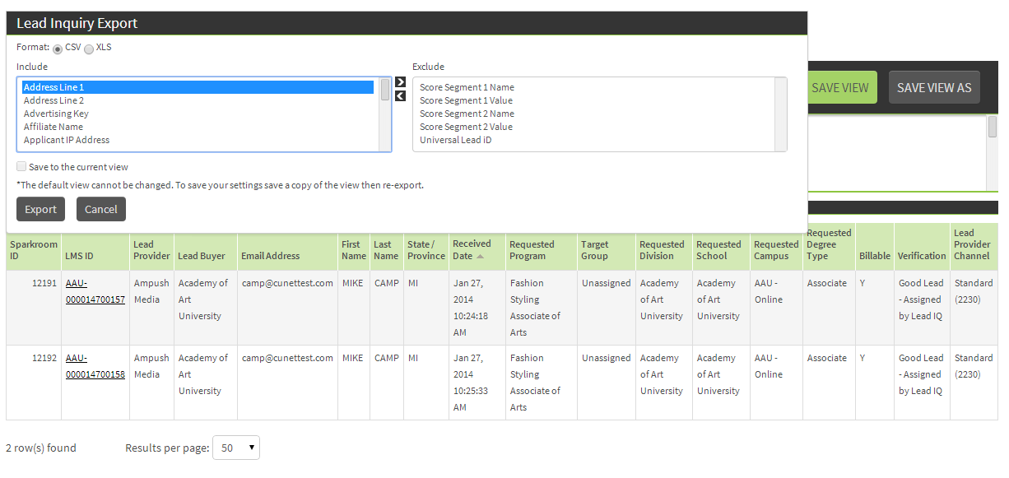
Congratulations, you have successfully generated a lead inquiry, saved it as a “view” so it can be accessed from the View Management screen, and exported the view!
For further information on this topic please contact support@sparkroom.com.

